ALGEBRAIC IDENTITIES
The name ALGEBRA is scary to many. But those are the basics of all Mathematical calculations and follows simple logic.

What is an algebraic Identity?
- Algebraic identities are an important set of formulas in Mathematics.
- It forms the foundation working principle of algebra
- It is helpful to perform computations in simple and easy steps.

How do they look?

- Algebraic identities are equations where the value of the left-hand side of the equation is identically equal to the value of the right-hand side of the equation.
- Unlike algebraic expressions, algebraic identities satisfy all the values of the variables.
For example: Consider the equations: 5x - 3 = 12, 10x - 6 = 24, and x² + 5x + 6 = 0. These equations satisfy only one value and do not work for any other values of the variables. Now consider x² - 9 = (x + 3)(x - 3). These equations satisfy any values of x.
From this, we can clearly understand that an algebra identity has an expression that satisfies any values for the variables.
- The basic algebraic identities are primarily helpful to work out the numerous mathematical problems.

- The basic algebraic identities are

- (a+b)² = a²+b²+2ab

- (a-b)² = (a²+b²-2ab)

- (a+b)²-(a-b)² = 4ab

- (a+b)²+(a-b)² = 2 (a²+b²)

- (a+b)(a-b) = (a²-b²)

- (a+b+c)² = (a²+b²+c²)+2(ab+bc+ca )

- (a+b)³ = a³+b³+3ab(a+b)

- (a-b)³ = a³-b³-3ab (a-b)

- (a³+b³) = (a+b)(a²+b²-ab)

- (a³-b³ ) = (a-b)(a²+b²+ab)

- Algebraic Identities for three variables:

The algebraic identities for three variables also has been derived using the binomial expansion formula. These identities are helpful to easily work across the algebraic expressions with the least number of steps.
- a² + b² + c² = (a + b + c)² - 2(ab + bc + ac)
- a³ + b³ + c³ - 3abc = (a + b + c)(a² + b² + c² - ab - ca - bc)
- (a + b)(a + c)(b + c) = (a + b + c)(ab + ac + bc) - 3abc

EXAMPLE 1:
Simplify ( 7x +4y )² + ( 7x - 4y )²
SOLUTION:
To solve this, we need to use the following algebraic identities:
(a + b)² = a² + 2ab + b²
(a - b)² = a² - 2ab + b²
Adding the above two formulas we have:
(a + b)² + (a - b)² = a² + 2ab + b² + a² - 2ab + b²
(a + b)² + (a - b)² = 2a² +2 b²
Here we have a = 7x and b = 4y. Substituting this in the above expression we have:
( 7x +4y )² + ( 7x - 4y )² = 2(7x)² + 2(4y)²
= 98x² + 32y²
Not only these, lengthy calculations can be easily done by using these identities. Check on these examples

EXAMPLE 2:
Using identities, solve 297 × 303.
SOLUTION:
297 × 303 can be written as ( 300 - 3 ) × ( 300 + 3 )
And this is based on the algebraic identity (a + b)(a - b) = a² - b²
Here we have a = 300, and b = 3
Substituting the values in the above identity, we get:
(300 - 3)(300 + 3) = 300² - 3²
= 90000 – 9
= 89991
Therefore 297 × 303 = 89991

Example 3:
Solve 1607 x 1607 ?
Answer:
Rewrite as (1607)² = (1600+7)²
We can notice the formula (a+b)² in above form. Hence we can solve this using
Formula: (a+b)²= a²+2ab+b^{2.}
(1600+7)² = 1600²+2(1600) (7)+7²
2560000+22400+49=2582449

Example 4:
Solve the expression (475×475) + (125×125)?
Answer:
We can notice the formula (a²+b²) in above form. Hence we can solve this using
Formula: (a²+b²) = 1/2[(a+b)²+(a-b)²]
=1/2[(475+125)²+(475-125)²]
=1/2[360000+122500] = 241250.
(or)
The expression may be given as (a+b)²+(a-b)²÷ a²+b²
In this case we know that (a+b)²+(a-b)² = 2(a²+b²).
Hence apply above formula in given expression as 2(a²+b²) ÷ a²+b² and cancellation occurred finally gives 2 as answer.

Example 5:
Simplify (893+786) ²- (893-786) ² ÷ (893×786)
Answer:
The given expression is in the following equation form
(a+b)²-(a-b)²÷ab=4
Explanation:By expanding as per formula a²+2ab+b²-(a²-2ab+b²) ÷ab
= a²+2ab+b²-a²+2ab-b²÷ab (cancellation occurs)
=4ab/ab=4.
EXAMPLE 6:
If 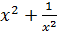 = 27, find the value of 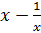.
SOLUTION: 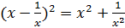 – 2*x*
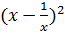= 27 – 2
= 25
= ± 5.

EXAMPLE 7:
If x + y = 12 and xy = 27, find the value of
SOLUTION:
We know that, (a+ b)³ = a³ +3a²b + 3ab² + b³
(x+ y)³ = x³ + y³+3xy(x+y)
12³= x³ + y³ +3*27(12)
1728 = x³ + y³ + 972
1728 – 972 = x³ + y³
x³ + y³ = 756

Example 8:
Evaluate: [(1786)² - (214)²]

Solution:
[(1786)² - (214)²] = (1786+ 214) (1786- 214)
= (2000) × (1572)
=3144000

Example 6:
Find the value of : 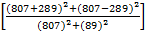

Solution:
Given Expression = 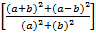, where a = 807 and b = 289
= 2
Example 7:
Find the value of : 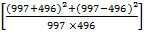
Solution:
Given Expression = 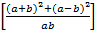, where a = 997 and b = 496
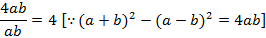
Example 8:
Evaluate:
Solution:
Given Expression = 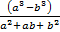, where a = 657 and b = 368
= (a-b) = (657 – 368) = 289

EXAMPLE 9:
If the area of a rectangle is 48m²n³ and whose length is 8mn², then what is the breadth?
SOLUTION:
Area of a Rectangle = Length * Breadth
48m²n³ = 8mn²*Breadth
Breadth = 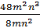
Breadth = 6mn

EXAMPLE 10:

SIMPLIFY: 2.45 x 2.45 - 0.9 x 2 45 + 0.45 x 0.45
Solution: Given expression
= 2.45 x 2.45 – 2.45 x 0.45 + 0.45 x 0.45
= (2.45)² – 2 x 2.45 x 0.45 + (0.45)²
= (2.45 – 0.45)² [∵ (a² -2ab + b² = (a-b)²]
= (2)² = 4.

EXAMPLE 11:
Simplify: 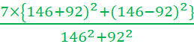

Solution: Given expression
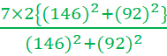 [∵ (a+b)² + (a-b)² = 2(a² +b²)]
=14.

EXAMPLE 12:

Simplify 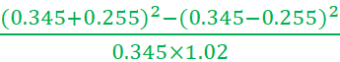
Solution: Given expression
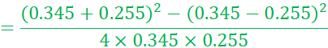

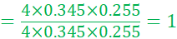 [∵ (a+b)² - (a-b)² = 4ab]

EXAMPLE 13:

Simplify 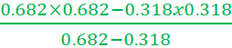
Solution: Given expression
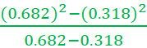 ∵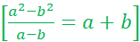
= (0.682+0.318) = 1

EXAMPLE 14:
Simplify: 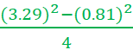
Solution: Given expression
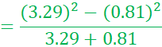
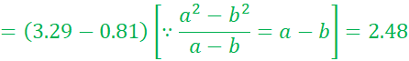
EXAMPLE 15:
Simplify: (2.35)³+1.95x(2.35)²+7.05x(0.65)²+(0.65)³
Solution: Given expression
=(2.35)³+3×0.65×(2.35)²+3×2.35x(0.65)²+(0.65)³
=(2.35+0.65)³
[]

EXAMPLE 16:
Simplify: 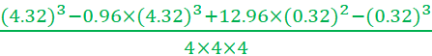
Solution: Given expression
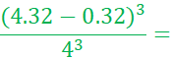
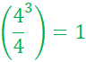

EXAMPLE 17:

Simplify :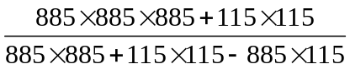
Solution: Given expression
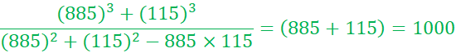
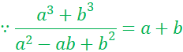

EXAMPLE 18:

Simplify : 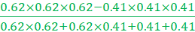
Solution: Given expression
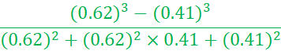

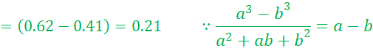

EXAMPLE 19:
Simplify: 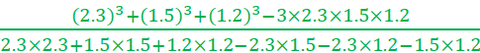
Solution: Given expression
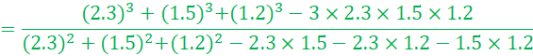

= (2.3 + 1.5 + 1.2) = 5 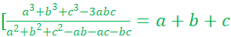]

EXAMPLE 20: Simplify :(47*47*47+35*35*35+ 26*26*26 -47*35*78)/(47*47+35*35+26*26- 47*35- 35*26-47*26)
Solution: Given expression is of the form
a³+b³+c³-3abc/ a²+ b²+c²- ab-bc -ca, where a =47 , b= 35, c= 26
=(a+b+c)
=(47+35+26)
= 108

